IBM Cloud Service

**Project Title**: Smart Solution for Railways **Team ID**: PNT2022TMID42986

Step 1: Search IBM CLOUD and click IBM cloud

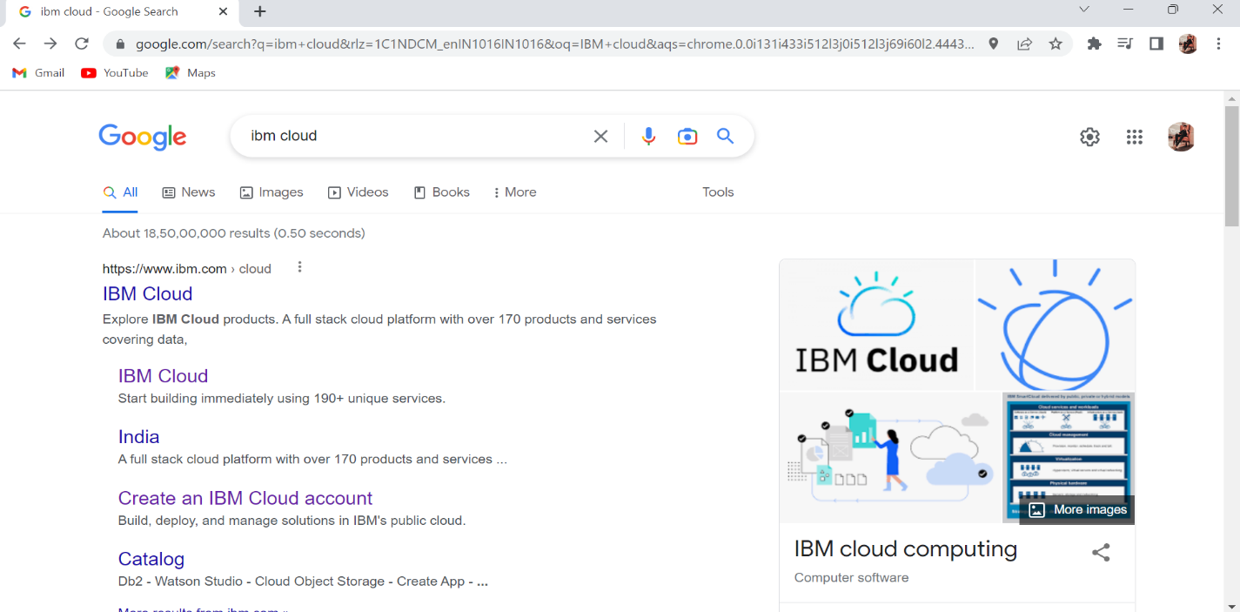

Step 2: If you new to IBM cloud then have go with create an account else then sign in with IBM cloud email ID is shown below.

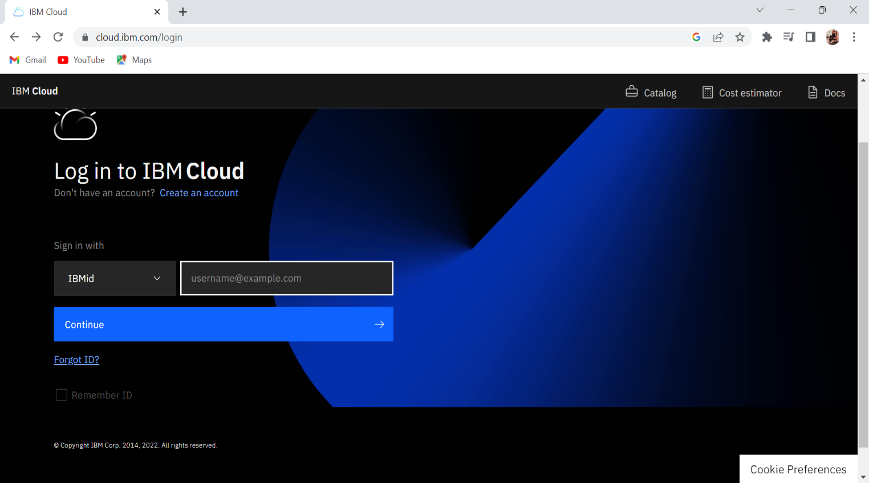

Step 3: After logged in IBM cloud.

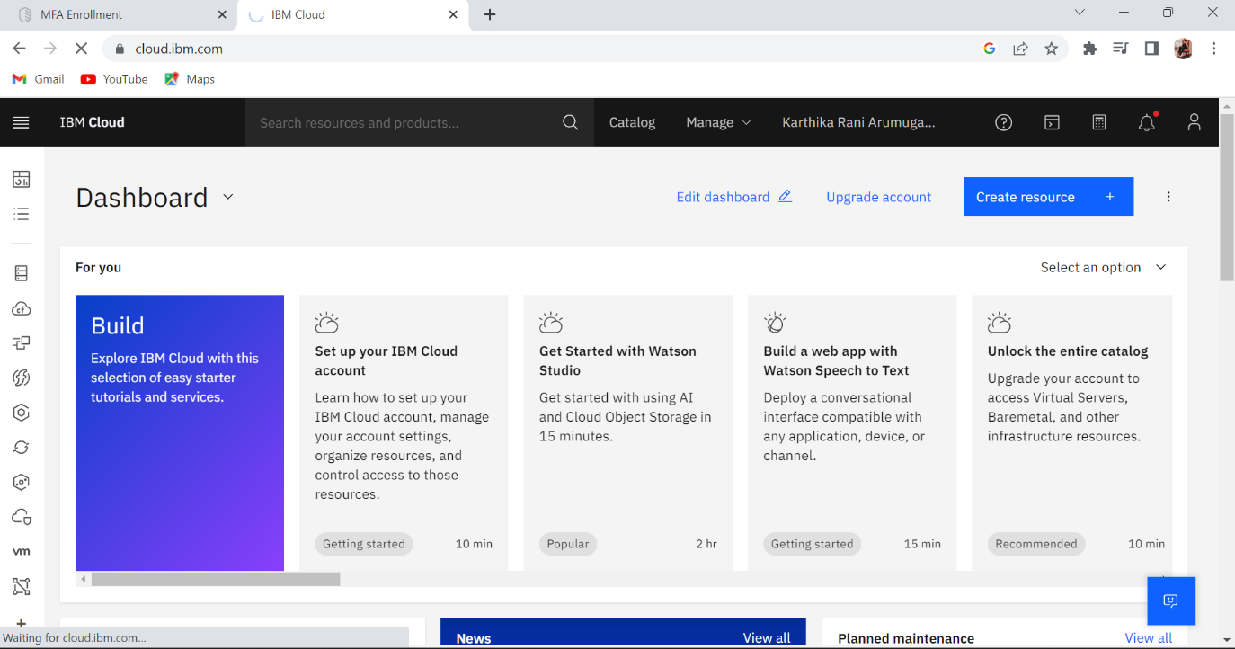

Step 4: If we want use any platform then have to click on catalog and it will direct us to many option like given below…

